Maths Questions

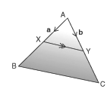 | Q: In the triangle ABC the points x and y are the mid points of AB and AC. Show the line XY is parallel to BC and half its length.  XY = ¹/₂ AC - ¹/₂ AB  XY = ¹/₂ (AC - AB) ← Sub BC = AC - AB  XY = ¹/₂ BC
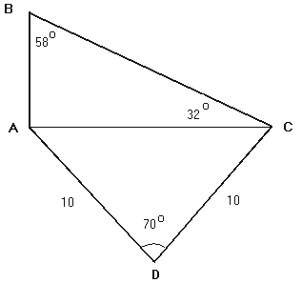 | Q: Find the length of side AB in the figure to the left
  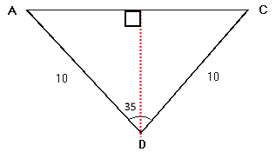 | sin(Ө) = O/C  sin(35) = ¹/₂ AC / AD  AC = 2sin(35)(10)  AC = 11.42  tan(Ө) = O/A  tan(32) = AB / AC  AB = tan(32)(11.42)  AB = 7.169
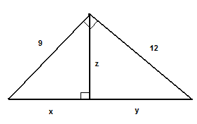 | Q: Find the lengths x, y and z  3 equations using pythagoras:  (x + y)² = 9² + 12²  12² = z² + y²  9² = z² + x²
  Rearrange 1:  (x + y)² = 9² + 12²  x = 15 - y | Substitute 3 from 2:  12² – 9² = z² + y² - (z² + x²)  63 = y² - x²  63 = y² - (15 - y)²  63 = y² – (225 - 15y -15y - y ²)  y = 9.6  x = 15 – 9.6 = 5.4 | Solve for z:  z² = 12² - y²  z = √(12² – 9.6²)  z = 7.2
Q: Find a, b and c so that the graph of the quadratic function f(x) = ax² + bx + c has a vertex at (-2, 1) and passes through the point (0,-3)

Vertex Form:  f(x) = a(x - h)² + k  f(x) = a(x + 2)² + 1 ← sub in (0, -3)  -3 = a(0 + 2) ² + 1  a = -1 | f(x) = a(x + 2)² + 1  f(x) = -(x + 2)² + 1 ← sub in 'a'  f(x) = -(x + 2)(x + 2) + 1  f(x) = -x² - 4x - 3 ← of the form ax² + bx + c  b = -4, c = -2

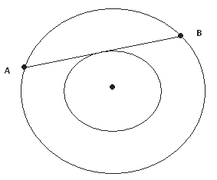 | Q: The two circles below are concentric (have same center). The radius of the large circle is 10 and that of the small circle is 6. What is the length of the chord AB?
  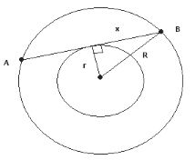 | r = radius of small circle = 6  R = radius of large circle = 10  x = ¹/₂ AB  r² + x² = R²  6² + x² = 10²  x = 8  AB = 16
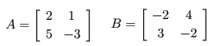 | Q: What is 2A + B^{T}?
  2A = | 4 2 |  | 10 -6 | | B^{T} = | -2 3 |  | 4 -2 | | 2A + B^{T} = | 2 5 |  | 14 -8 |
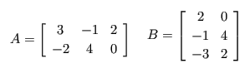 | Q: What is AB?  AB = | (3*2) + (-1*-1) + (2*-3) (3*0) + (-1*4) + (2*2) | = | 1 0 |  | (-2*2) + (-1*4) + (0*-3) (-2*0) + (4*4) + (0*2) | | -8 16 |
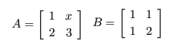 | Q: If AB = BA then what is the value of x?
  AB = | 1+x 1+2x |  | 5 8 | | BA = | 3 x+3 |  | 5 x+6 | | 1+x = 3 as AB = BA  x = 2

